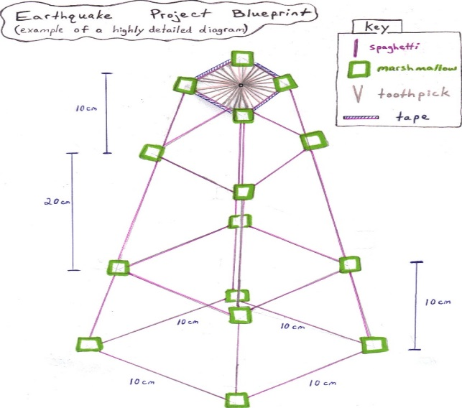**Earthquake-Proof Skyscrapers**

**Goal** - *Research, design, and construct an earthquake-proof structure made of spaghetti, marshmallows, and masking tape able to support, protect, and hold an egg 40 cm from its surface during a simulated earthquake.*

***Suggested Timeline:***

(Day 1) - Research and record information for the project. You may use the websites listed below or conduct your own research.

* How to Make Earthquake Proof Structures - <http://www.reidsteel.com/information/earthquake_resistant_building.htm>
* Building Skyscrapers - <http://www.pbs.org/wgbh/buildingbig/skyscraper/index.html>
* Exploratorium: Building at the Fault Line - <http://www.exploratorium.edu/faultline/index.html>
* Earthquake Proof Skyscrapers - <http://www.odec.ca/projects/2007/nart7r2/earth.html>

*Hint – Search websites that provide information on building structures able to withstand earthquakes or other natural disasters. Use the information found to help you engineer and design your structure.*

(Days 1-2) - After researching information related to earthquake-proof structures, all group members create a **scaled** blue print of their structure using standard size 8 ½ by 11 graph paper (*see above image*). Each team will vote on the design to construct for the final simulated earthquake test.

*Things to Consider:*

* Structures should be strong, yet flexible. Your actual structure must closely match your original blue print. Only minor changes will be allowed.
* Designs must fall within a budget of $4875.00. See material costs below:

|  |  |  |
| --- | --- | --- |
| **Product** | **Cost** | **Item Number** |
| Spaghetti Sticks (uncooked) | $100.00/stick | SPA-1234 |
| Mini Marshmallows | $50.00 (1 marshmallow) | MAR-5678 |
| Masking Tape | $25.00 (1 inch of tape) | TAP-9000 |

*Rules for use of Materials:*

* *Spaghetti sticks may not be broken into pieces smaller than ¼ of the stick.*
* *Marshmallows must remain intact. Do not tear or break into smaller pieces.*
* *You must use only the materials your team purchases in class. You may not bring in your own materials or use materials from another team.*
* *You may not tape your structure to the table/the tape can only be used to hold your structure together/reinforce.*

(Days 3-4) –Purchase Materials and Construct Structure

Purchase materials from the *Construction Supply Store*. To purchase materials you must write a check for the amount your team is spending.

You are responsible for keeping track of how much money is spent and how much money is left. Checks will be provided to you by the banker (Mr. Smith). You only have 3 checks to use.

Remember, your total budget for all materials is **$4,875.00. Exceeding your budget will result in a 20 point deduction to the overall project grade.**

Use the table below to keep track of your expenses:

|  |  |  |  |  |  |  |  |
| --- | --- | --- | --- | --- | --- | --- | --- |
| **Date of Purchase** | **Description of Purchase** | | | | | **Total Deduction** | **Balance**  **($4875.00)** |
|  | **Item Number** | **Quantity** | | **Cost/Unit** | **Total Cost** |  |  |
| SPA-1234 |  | |  |  |
| MAR-5678 |  | |  |  |
| TAP-9000 |  | |  |  |
|  | **Item Number** | **Quantity** | **Cost/Unit** | | **Total Cost** |  |  |
| SPA-1234 |  |  | |  |
| MAR-5678 |  |  | |  |
| TAP-9000 |  |  | |  |
|  | **Item Number** | **Quantity** | **Cost/Unit** | | **Total Cost** |  |  |
| SPA-1234 |  |  | |  |
| MAR-5678 |  |  | |  |
| TAP-9000 |  |  | |  |

**Ending Balance _________________**

Individual Design (50 points)

After research, each member of the group must make an architectural (scaled) drawing of the structure on graph paper.

Final Group Design (25 points)

The Build (25 points)

Earthquake Test (100 points)

“Spaghetti” Earthquake Rubric

|  |  |  |  |  |
| --- | --- | --- | --- | --- |
|  | **9 – 10**  **points** | **7 – 8**  **points** | **5 – 6**  **points** | **0 – 4**  **points** |
| **Diagram (Blueprint)** | Diagram drawn extremely well.  Professional look.  Highly detailed.  Parts labeled.  Easy to understand. | Diagram drawn  Satisfactorily.  Drawing neat.  Good detail.  Most parts labeled.  Understandable | Diagram messy.  Not labeled.  Some detail.  Difficult to read or understand. | No diagram turned in.  Poor or sloppy drawing.  Very difficult to read or understand. |
| **Use of Materials / Clean-up** | Materials properly used and cared for.  No materials wasted.  Area cleaned up thoroughly by the bell. | Materials used properly but some wasted material.  Area reasonably cleaned up by the bell.  Materials being put away at bell. | Some or most materials wasted damaged or lost.  Area not clean by the time bell rings.  Materials put away after bell. | Most materials lost, damaged or wasted.  Work area left a mess. |
| **Team Cooperation** | Group works very well together. Ideas from all members listened to and respected.  Excellent participation.  Appropriate discussion of topic. | Group works adequately well. For the most part ideas respected and listened to by all members.  1 or 2 warnings given for lack of cooperation or participation.  Some arguing or inappropriate discussion. | Group not cooperating. Not respecting or listening to others.  3 or more times warned for lack of cooperation or not participating.  Arguing or inappropriate discussion. | Group not attempting to work or cooperate.  Inappropriate discussions not related to project.  Total lack of participation. |
| **Group Presentation / Internet Research** | Well presented. Presentation shows evidence of planning  Two or more examples of research given.  Excellent description of how research applies to project. | Presentation good. Some evidence of planning.  One or two examples of research  Good description of how research applies. | Presentation weak. Little planning.  One example of research given.  Weak description of how research applies. | Presentation poor - little or no planning shown.  No examples of research given.  Poor description of how research applies. |
| **Building of Structure / Design** | Very well built. Supports egg easily without leaning or swaying.    Project requirements are met and exceeded.  Project completed on time. | Structure stands on own but leans or wobbles. Will support egg.  Project requirements are met.  Completed on time. | Structure stands but will not support egg.  Most project requirements are met.  Requires extra time to complete project. | Structure will not stand on own. Will not support egg.  Project requirements are not met.  Structure not finished even with extra time. |
| **Final**  **Test** | Egg does not fall and structure remains intact for 10 sec. | Egg falls but structure remains intact and standing for 10 seconds | Egg falls.  Structure breaks or falls within 10 sec. | No test / No structure.  Structure so poorly built it cannot be tested. |

*Points can be deducted on an individual basis. These deductions will only affect the individual and not the entire team. Examples of individual deductions are listed in the special instructions.*

|  |
| --- |
| ______________________________________ 71-758/698 Check No. 1001  ___________________________________  PAY TO THE  ORDER OF ___________________________________________________________________ $ _____________________________  ___________________________________________________________________________________________  LCHS Science Dept.  State Bank  Memo ________________________________ __________________________________________________________  Company Representative  0000753d57##**:// 887532//; LL99654# |

|  |
| --- |
| ______________________________________ 71-758/698 Check No. 1002  ___________________________________  PAY TO THE  ORDER OF ___________________________________________________________________ $ _____________________________  ___________________________________________________________________________________________  LCHS Science Dept.  State Bank  Memo ________________________________ __________________________________________________________  Company Representative  0000753d57##**:// 887532//; LL99654# |

|  |
| --- |
| ______________________________________ 71-758/698 Check No. 1003  ___________________________________  PAY TO THE  ORDER OF ___________________________________________________________________ $ _____________________________  ___________________________________________________________________________________________  LCHS Science Dept.  State Bank  Memo ________________________________ __________________________________________________________  Company Representative  0000753d57##**:// 887532//; LL99654# |